Summary
I chose to use genetic algorithms (GA) to evolve patterns for a particular cellular automata (CA) that I’ve been developing for a video game idea. The game itself relies on the components of GA i.e. evolution, cross-over and mutation. The idea is that the player must build a matrix pattern for a “virus” that will run through the CA rules I’ve designed against other players’ viruses to “infect” a third grid of “flesh”. The player whose virus spreads the quickest and with the larger spread wins. Once a player has won, they earn new building blocks of viruses which are essentially smaller patterns evolved from both players’ pattern sets.
My use of GA here is to evolve the starting smaller patterns for players to build from. All I’m really looking for are patterns that give interesting CA animations. The chromosome of a pattern is a grid of values representing the indeces of states used in the CA. Since I’m constraining this grid to 5x5 the chromosomes are twenty-five integers from zero to three inclusive. The fitness is computed by running the CA for ten iterations while counting three features. The first feature is how many “decay” states appear, where “decay” means infection of the flesh grid in the game. The second is the spread which is the average distance from the center that the infection moves. The last feature is the furthest distance of spread that a “decay” state is from the center.

Technical Components
Because of the complexity of using GA with CA, I had to restrict the population size and number of generations to 20. Originally I had these set to 100 and 50 respectively, but I estimated that to take 20 hours to complete. Because of the small population and generations, I used a random binary mask for mutation and vanilla two point crossover. The genes aren’t binary encoded so the mutation technique is actually iterating through the genes and randomly deciding whether or not to change. Changing a gene means rotating through the available states, which seemed to work just fine.
The selection method is the common roulette wheel. I provide the selection function with an array of tuples containing the chromosomes and their fitness values in sorted order. The function then iterates through summing up the total fitness while adding the current total onto each tuple’s fitness value. With this setup, I choose a random number from zero to the fitness sum to select the chromosome whose fitness is greater than the number while the predecessor’s fitness is less.
To prevent each successive generation from being worse than the previous, I allowed one chromosome to persist on each new generation. The chromosome selected is the one with the highest fitness of the current generation, but I allowed a full new generation to be created before adding. In this scenario I am able to drop the least fit of the new generation to be replaced with the elite. I’m considering this an abortive elitism as I’m removing a new child to allow the elite through. This method improves slightly the common elitism by not only guaranteeing the next best to be no worse than the current, but also pruning the worst of the new generation. To keep from adding complexity by computing the fitness if a single chromosome more than once, I adjusted the chromosome class to use memoization and only compute it once. This only affects the elite chromosomes.
Algorithm
Here is the main loop of the genetic algorithm
collect fitness values
newGeneration = Select( @populationSize, Array of tuples [ (chromosome, fitness)] )

## cross-over
For each pair of chromosomes
if rand() < @probCross
Crossover ( chromosome1, chromosome2 )
End
end
## mutation
For each chromosome
if rand() < @probMutate
Mutate( chromosome )
end
end
sort new generation based on fitness
## Elites do not mutate or cross-over
## this method is some sort of abortion, btw
For each elite
Worst chromosome in new generation = elite chromosome
end
resort new generation if we had elites
@population = new Generation
@generation += 1
Here is the roulette wheel selection
#pop is the sorted list of chromosome + fitness pairs (highest fitness at lowest index)
def RouletteSelection (num, pop) {
sumFit = 0

# sum all fitness values and add the current sum to each value
for p in pop
f = p[1]
p[1] = sumFit + p[1]
sumFit += f
end

length = pop[0][0].length #length of the chromosome
selection = []
(1..num).each { |i|
r = rand(sumFit)
pop.each { |p|
# loop through chromosomes stopping to add when adjusted
#fitness is less than random number
if r < p[1]
# make a deep copy of the chromosome and add to list
selection.push(p[0].dclone)
break
end
}
}

return selection
}

Results
After evolving twenty populations, I took several chromosomes from each batch and ran them through the visual CA I had created. I noticed that each set seemed to display certain common traits such as overall shape, longevity (time until CA convergence), and presence of attributes such as spirals.
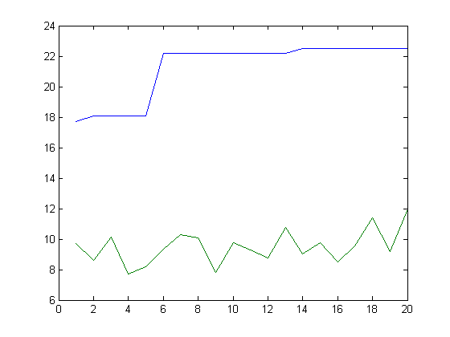
Best and Worst chromosome fitness, X is generation Y is fitness

These common attributes suggest to me that my small population size caused each chromosome to have some close relationship to each other. Inspecting the resulting chromosomes you can see that a subset of the population is very similar. For instance, in one batch there are fourteen chromosomes that appear to be very similar. Running them through the visual CA engine shows that this large group had a circular spread while the other group created two waves that ended up spiraling out into each other.
In all cases, the best fitness did improve with the twenty generation limit. On average this was an overall increase of five, which is about one quarter of the end fitness and roughly a %27 increase from the initial. However, in each case the best fitness follows a stair pattern of improvement. This seems to indicate that allowing one elite lead the overall improvement in each case. Without knowing much of the population at each generation, I can’t make any estimation whether the crossover or the mutation is driving the underlying growth.
I’m hoping to continue using this while updating my fitness calculation to come up with new types of viruses. By inspecting my current results I should be able to determine what aspects of my fitness calculation are giving interesting results and build new calculations to maximize those interesting features.

